|  |
| --- |
| TS021 - Create Report (Test for Duplicate Report): Concern Type = Streetlight Concern; By Guest User |

|  |
| --- |
| TC058_Create Report (Test for Duplicate Report): Concern Type = Streetlight Concern; By Guest User |

|  |
| --- |
| Step 1 - Access outage reporting form for Guest users. |
| User should be able to access outage reporting form for Guest users. |

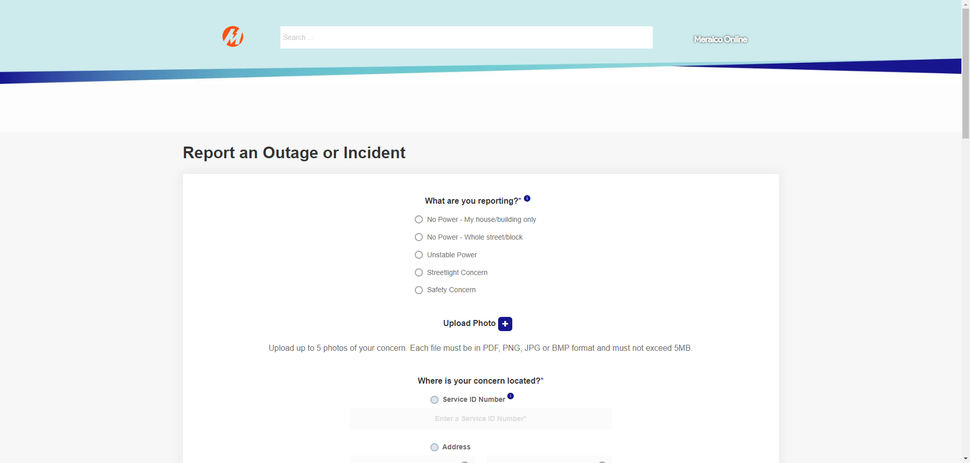

|  |
| --- |
| Step 2 - Choose 'Streetlight Concern' from the 'What are you reporting?' option. |
| The following questions should appear: Q1: Is this streetlight connected to a Meralco Pole? |

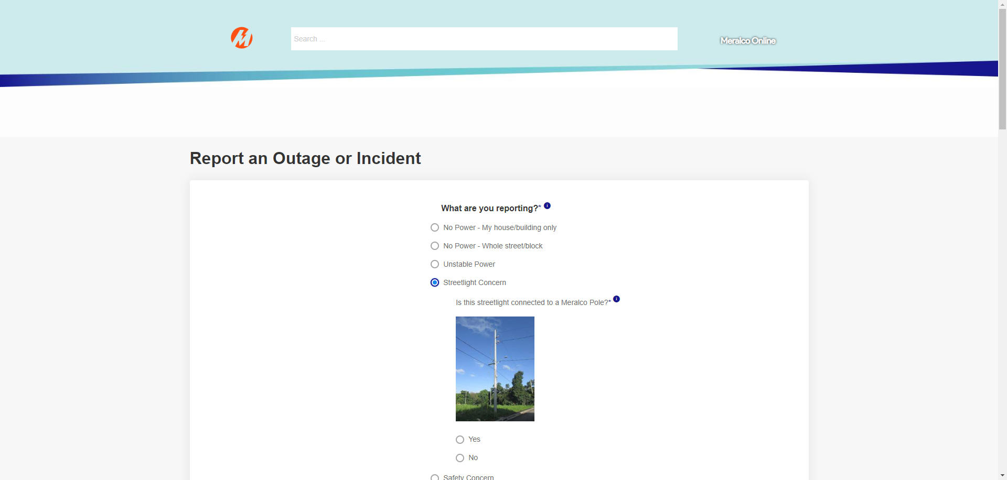

|  |
| --- |
| Step 3 - Choose 'Yes' from the options. |
| The following questions should appear: Q2: What’s wrong with the Meralco Streetlight? |

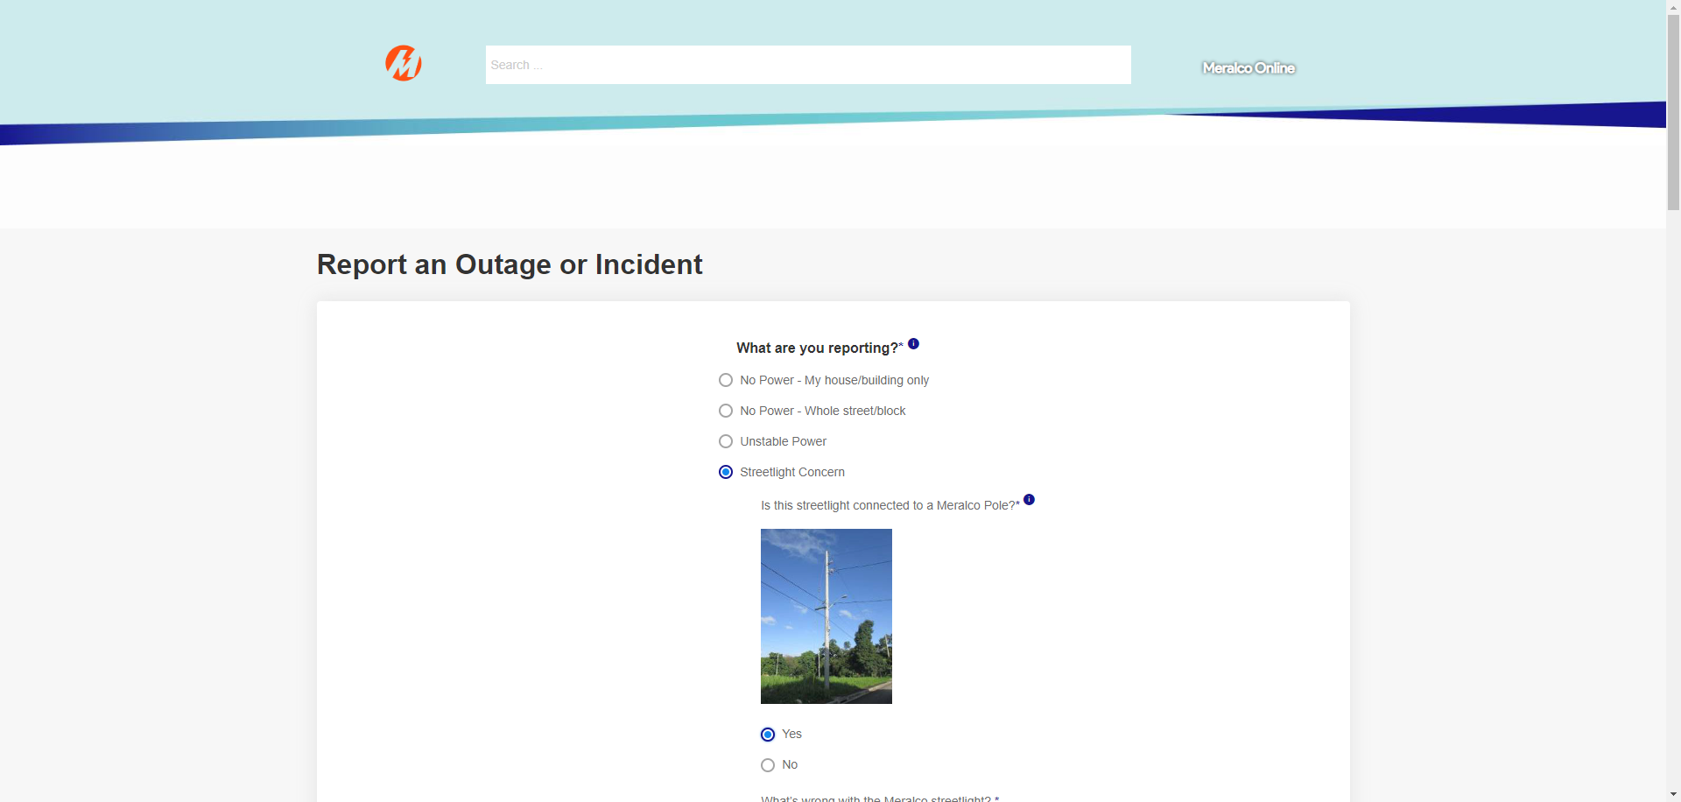

|  |
| --- |
| Step 4 - Click the dropdown field for Q2. |
| The following options should appear: • Streetlight is always on, even during daytime • Streetlight is flickering • Streetlight is not on or has no power • Streetlight fixture is damaged or has broken bulbs |

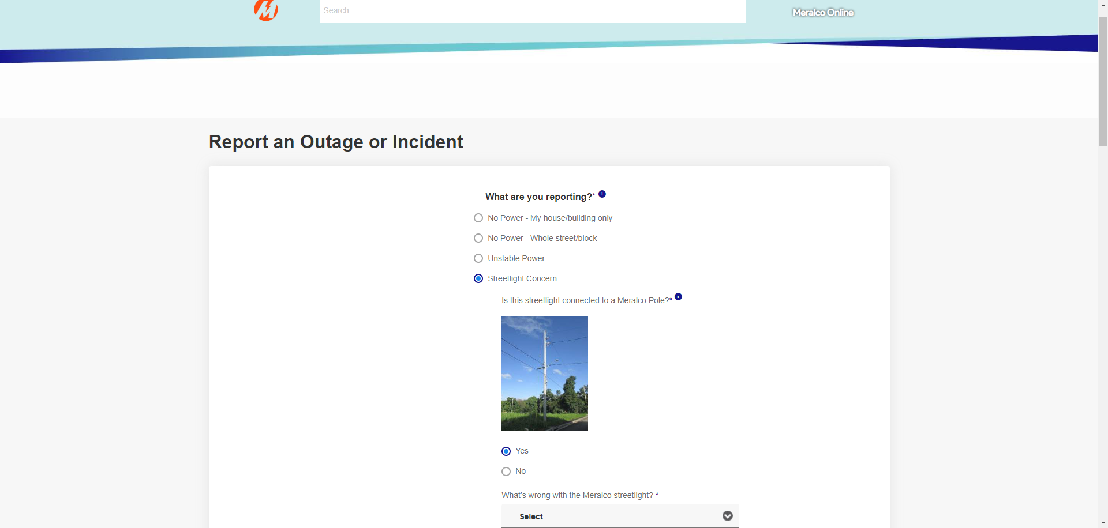

|  |
| --- |
| Step 5 - Choose 'Streetlight is always on, even during daytime' from the option. |
| The dropdown field for Q2 should be populated. |

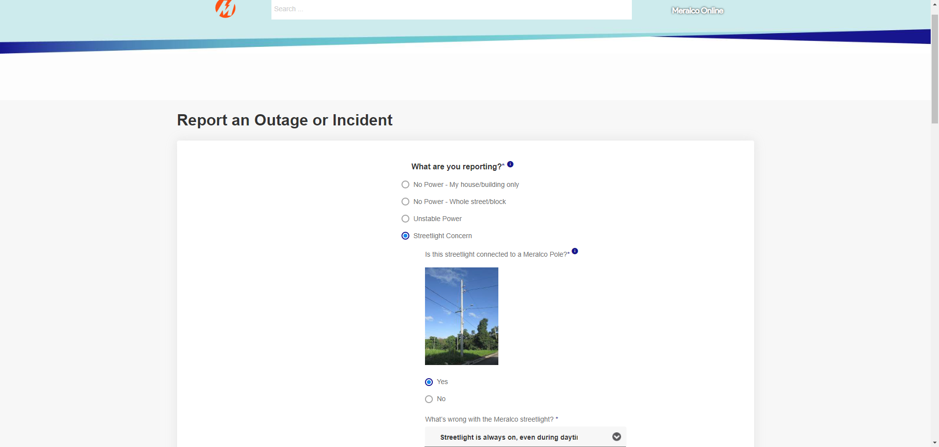

|  |
| --- |
| Step 6 - Populate the following fields by selecting from one of the picklist values, as applicable: - Province - City/Municipality - Barangay - Subdivision - Street - House/Unit No./ Floor/ Building |
| Fields should be populated. |

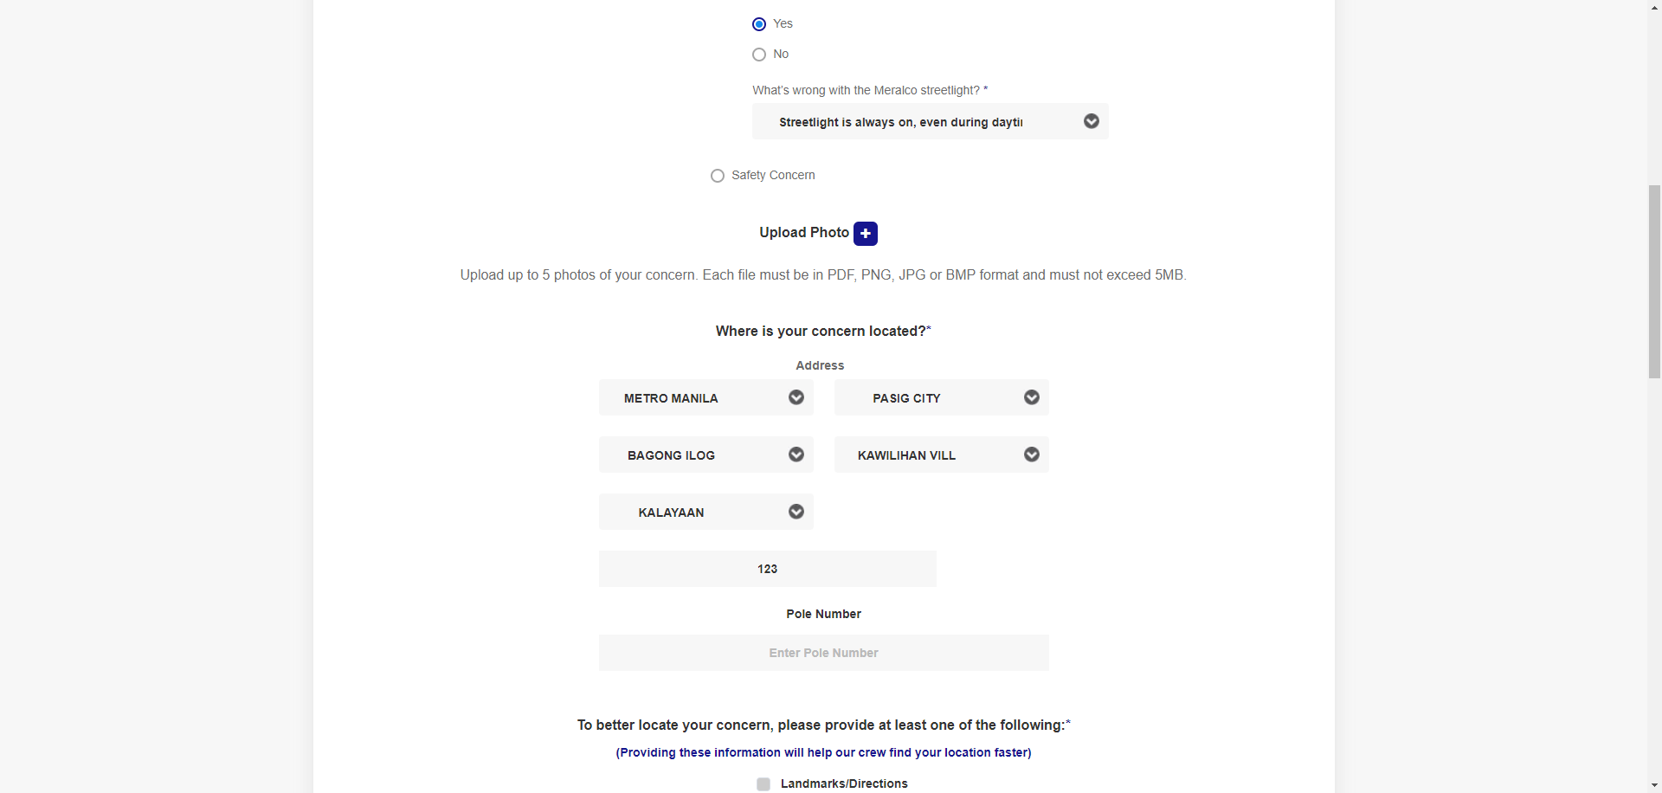

|  |
| --- |
| Step 7 - Populate 'Pole Number' field. Note: There should be no pending case associated to the encoded Pole Number. |
| Fields should be populated. |

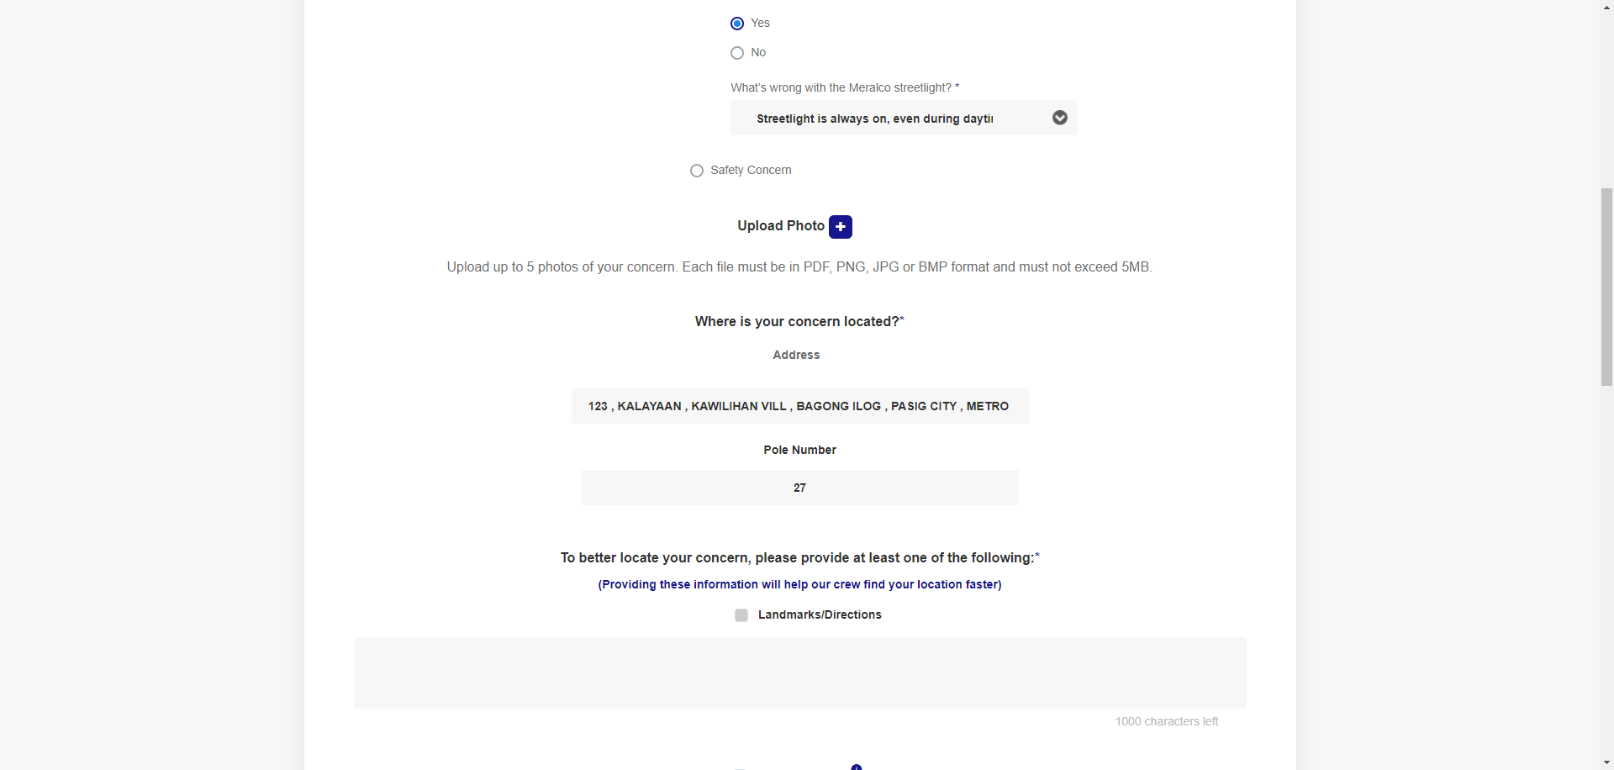

|  |
| --- |
| Step 8 - Select the 'Landmarks/Directions' option and input values in the text box. |
| Landmarks/Directions' field should be populated. AND Character count should not overlap with inputted values.  Note: A maximum of 1,000 characters should be accepted. |

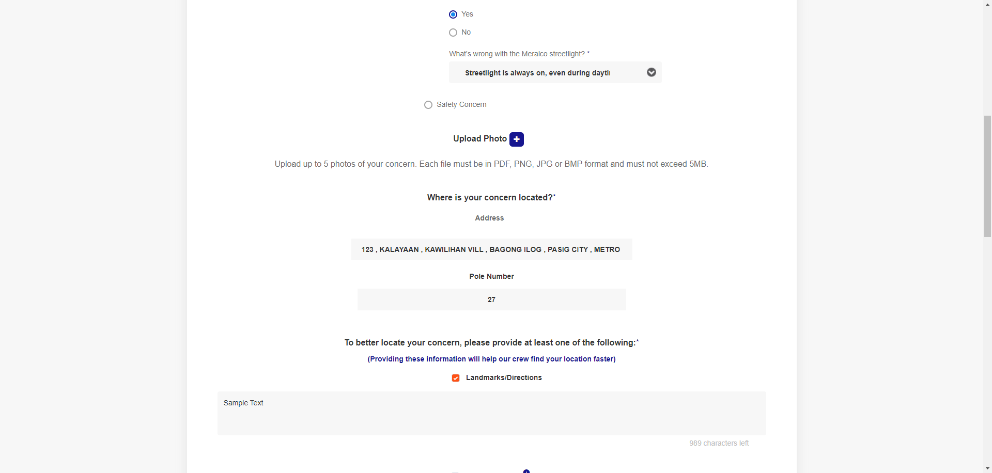

|  |
| --- |
| Step 9 - Populate the following fields: a) First Name b) Middle Name c) Last Name d) Mobile Number e) Landline f) Email |
| Fields should be populated. |

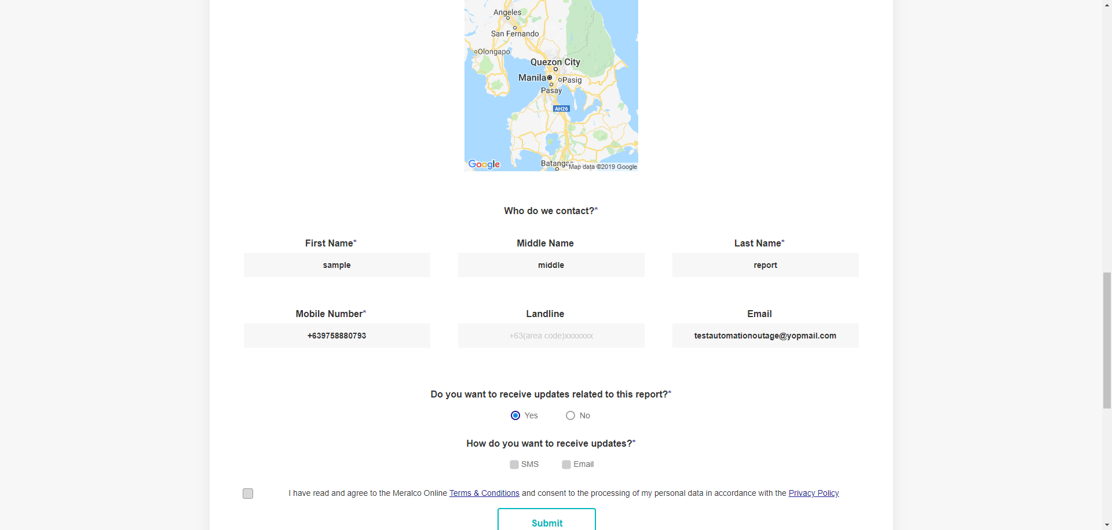

|  |
| --- |
| Step 10 - Verify if 'Yes' is selected from the options under 'Do you want to receive updates related to this report?' |
| Yes' is selected by default from the options under 'Do you want to receive updates related to this report?' |



|  |
| --- |
| Step 11 - Select SMS and Email as preferred Case Notification Channel. Note: Ensure that 'Email' field has valid value if Email has been selected as preferred Case Notification Channel. |
| Preferred Case Notification Channel has been selected. |

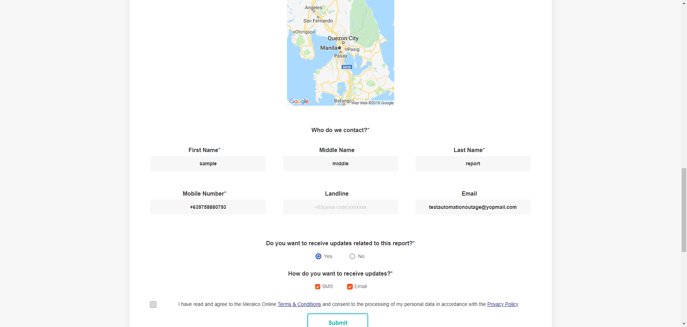

|  |
| --- |
| Step 12 - Select the checkbox for: I have read and agree to the Meralco Online Terms & Conditions and consent to the processing of my personal data in accordance with the Privacy Policy. |
| User has agreed to the Meralco Online Terms & Conditions. |

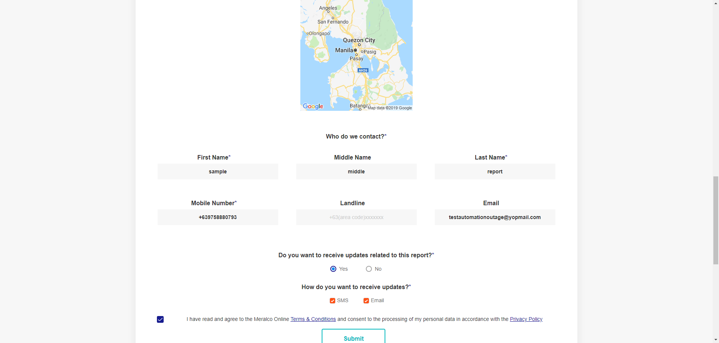

|  |
| --- |
| Step 13 - Click ‘Submit’ button. |
| The following message should be displayed:  We've received your report! Your Reference No. is [Case Number].  We'll also send you updates as soon as they're available. |

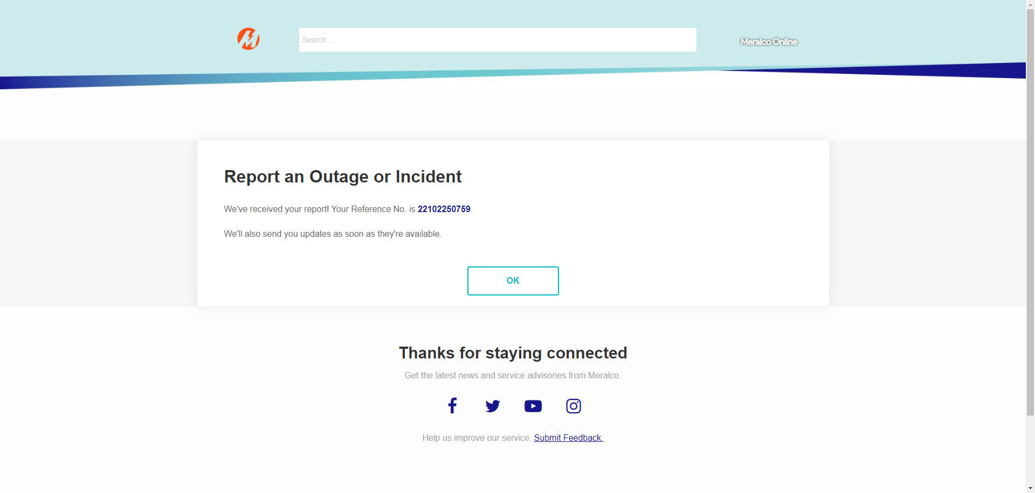

|  |
| --- |
| Step 14 - Verify received SMS notification. |
| User was able to receive one SMS notification, with template below.  We’ve received your report with Ref.# [Case Number]. We’ll send you updates as soon as they become available. Thanks. |

|  |
| --- |
| Step 15 - Verify received Email notification. |
| User was able to receive one Email notification, with template below.  Subject: Acknowledgement Receipt of Report   Hi [First Name],   We’ve received your report with Reference No. [Case Number]. We’ll send you updates as soon as they become available.   To conveniently check the status of your report, register or log in to Meralco Online. |

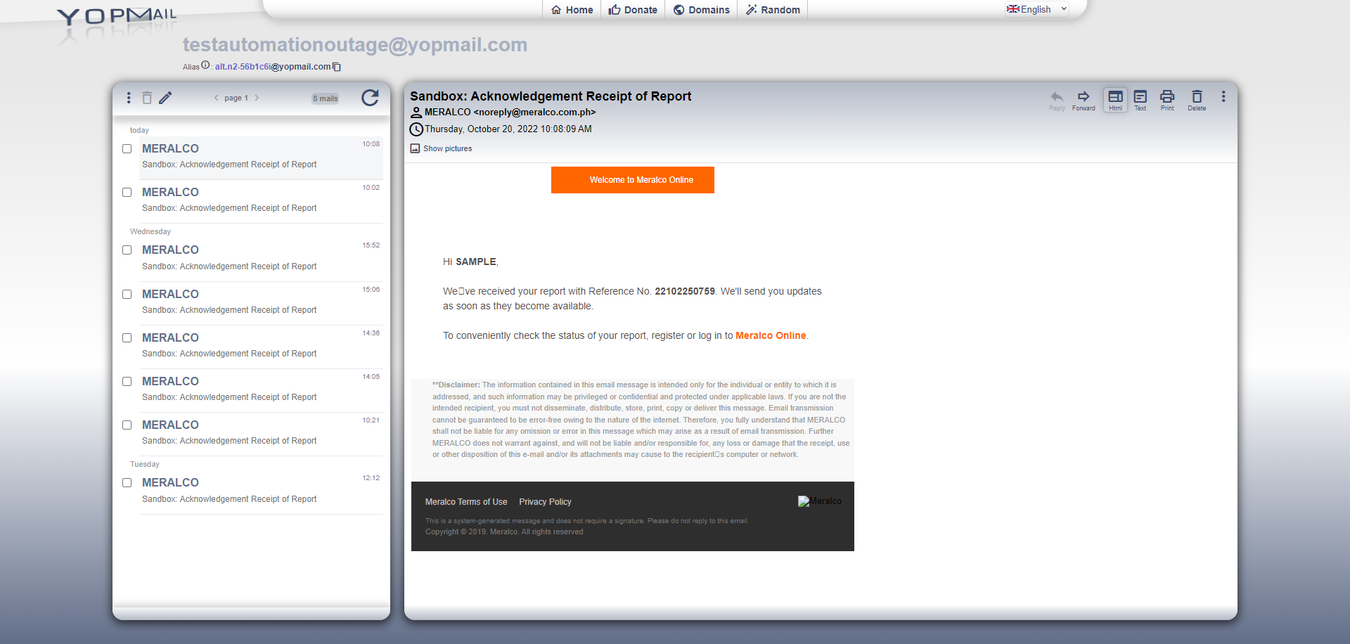

|  |
| --- |
| Step 16 - Access outage reporting form for Guest users. |
| User should be able to access outage reporting form for Guest users. |

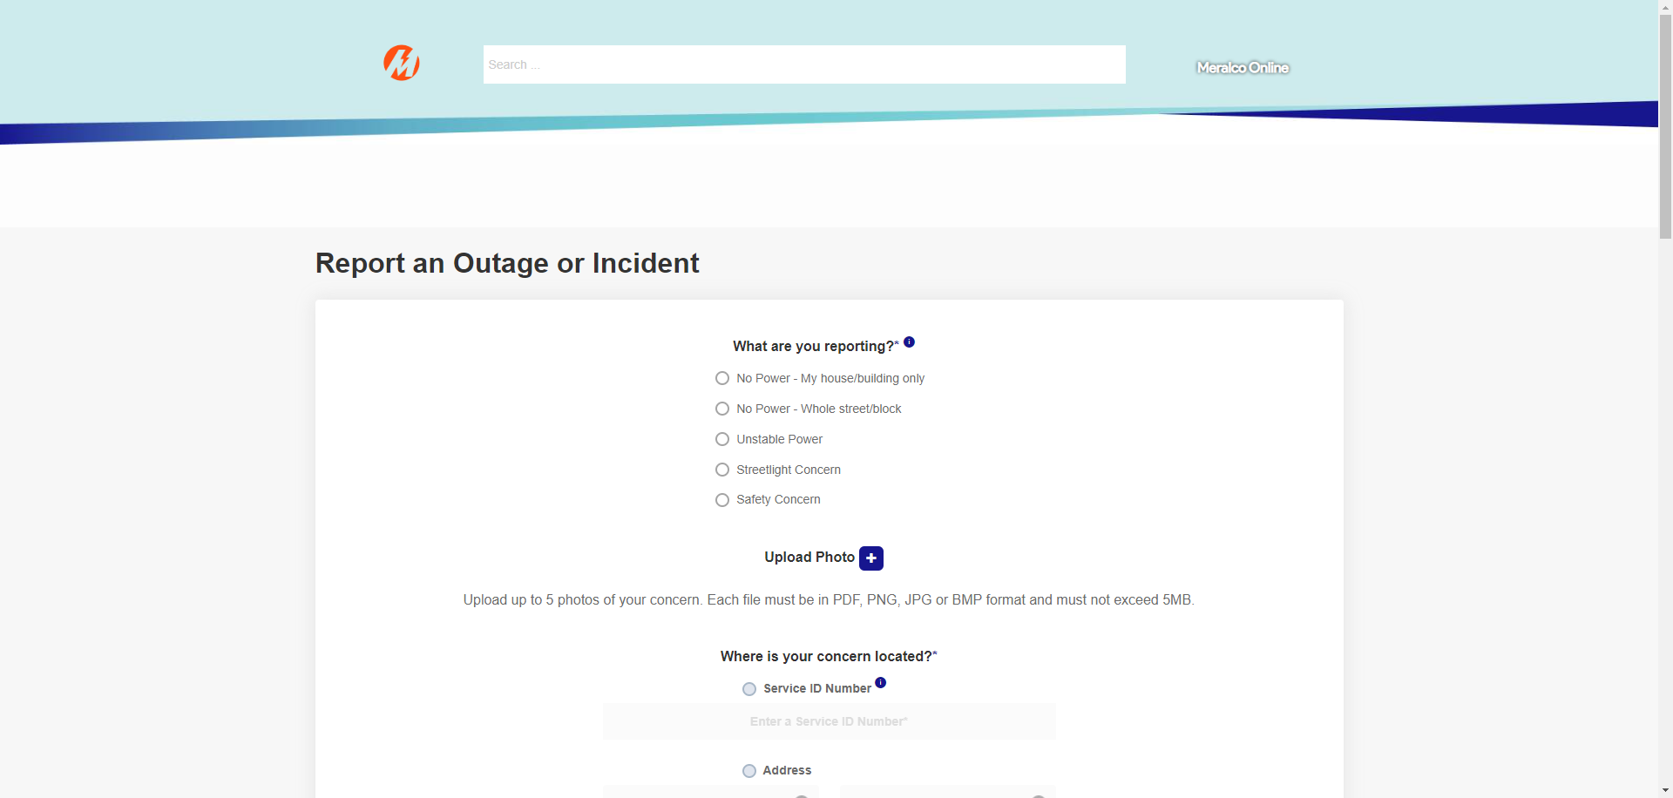

|  |
| --- |
| Step 17 - Choose 'Streetlight Concern' from the 'What are you reporting?' option. |
| The following questions should appear: Q1: Is this streetlight connected to a Meralco Pole? |

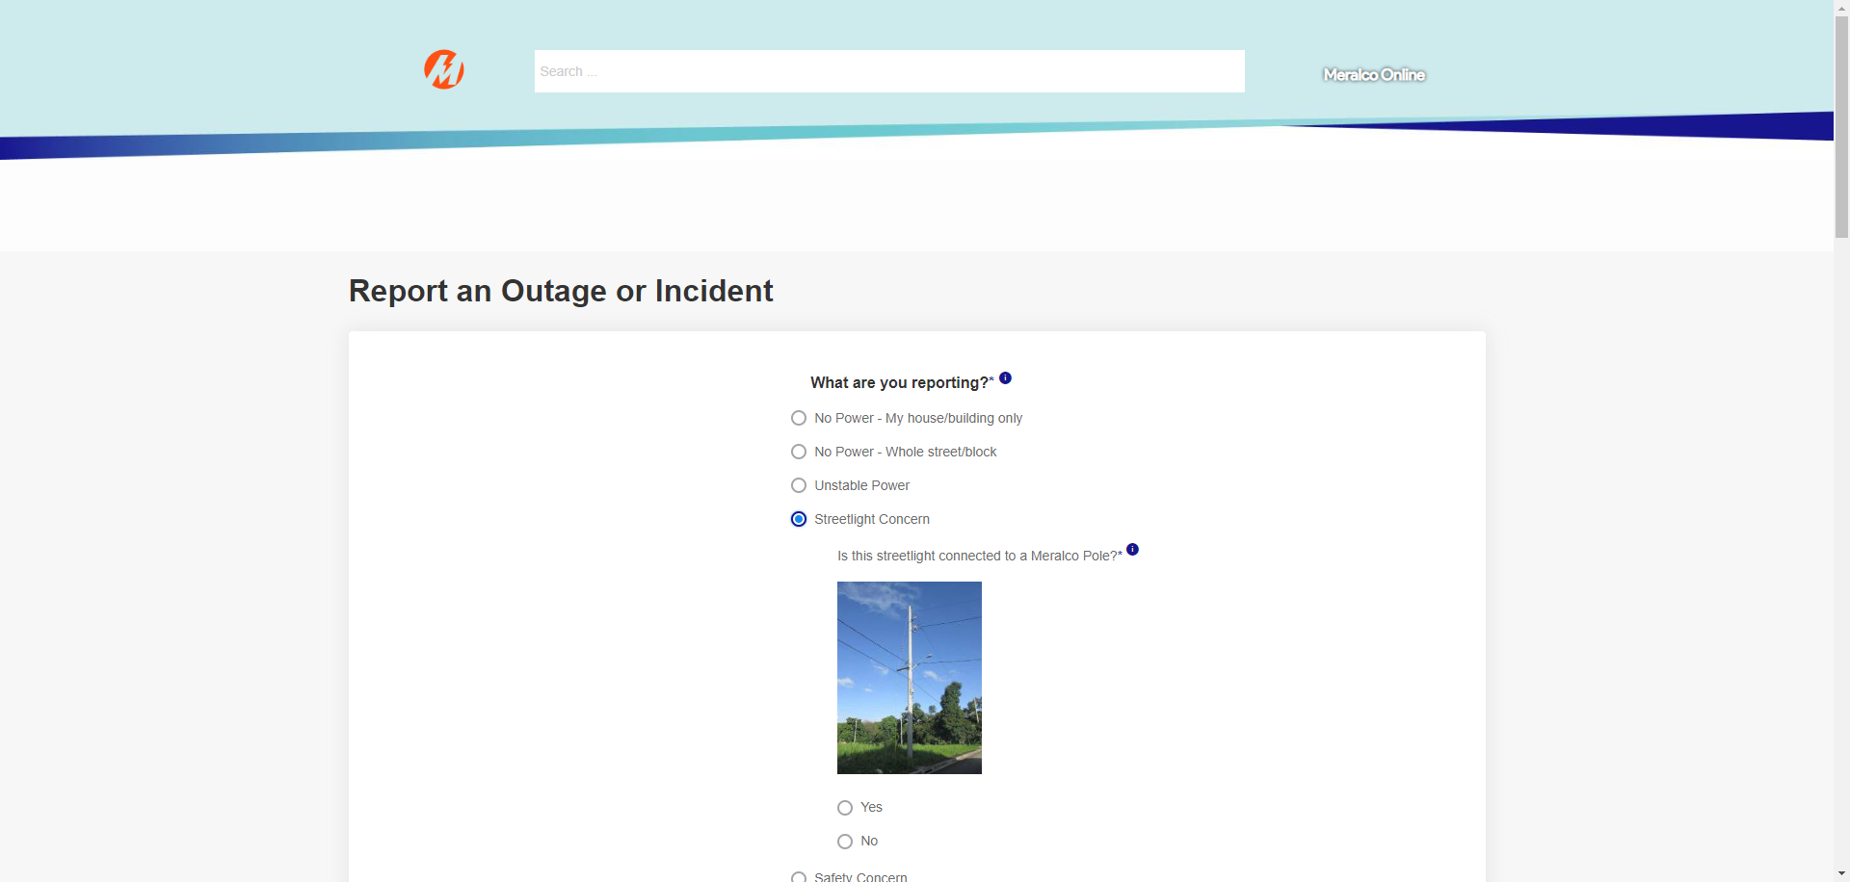

|  |
| --- |
| Step 18 - Choose 'Yes' from the options. |
| The following questions should appear: Q2: What’s wrong with the Meralco Streetlight? |

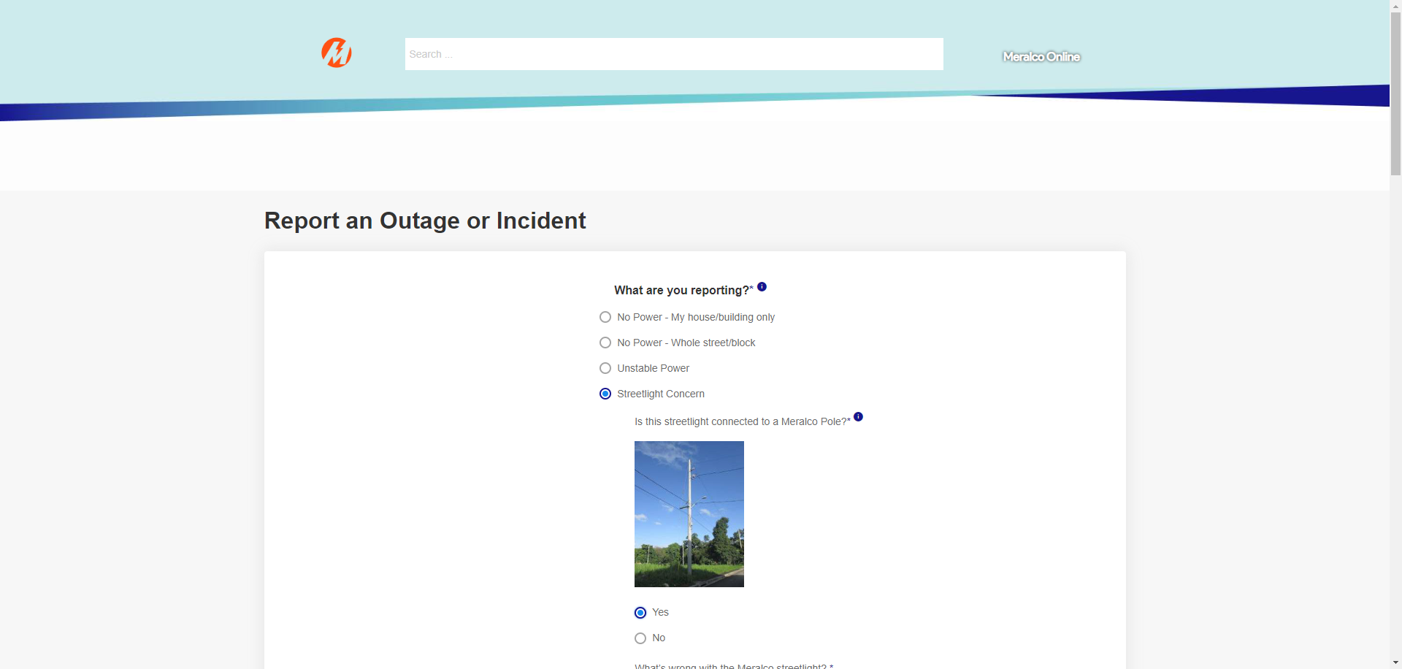

|  |
| --- |
| Step 19 - Click the dropdown field for Q2. |
| The following options should appear: • Streetlight is always on, even during daytime • Streetlight is flickering • Streetlight is not on or has no power • Streetlight fixture is damaged or has broken bulbs |

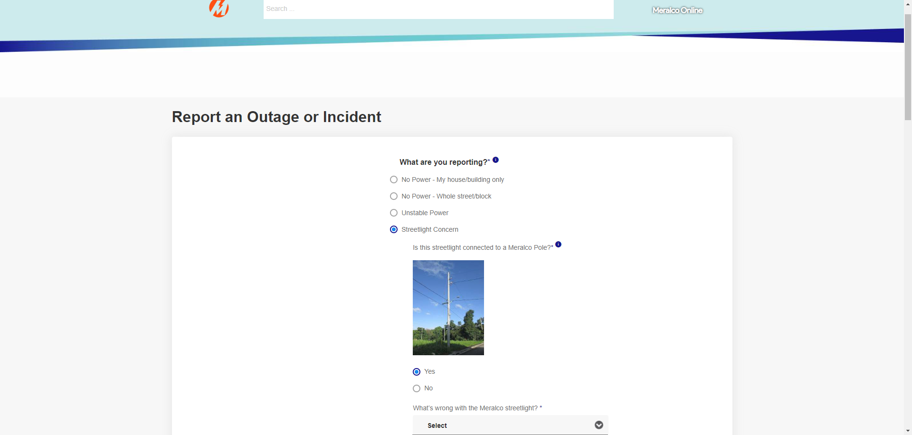

|  |
| --- |
| Step 20 - Choose 'Streetlight is flickering' from the option. |
| The dropdown field for Q2 should be populated. |

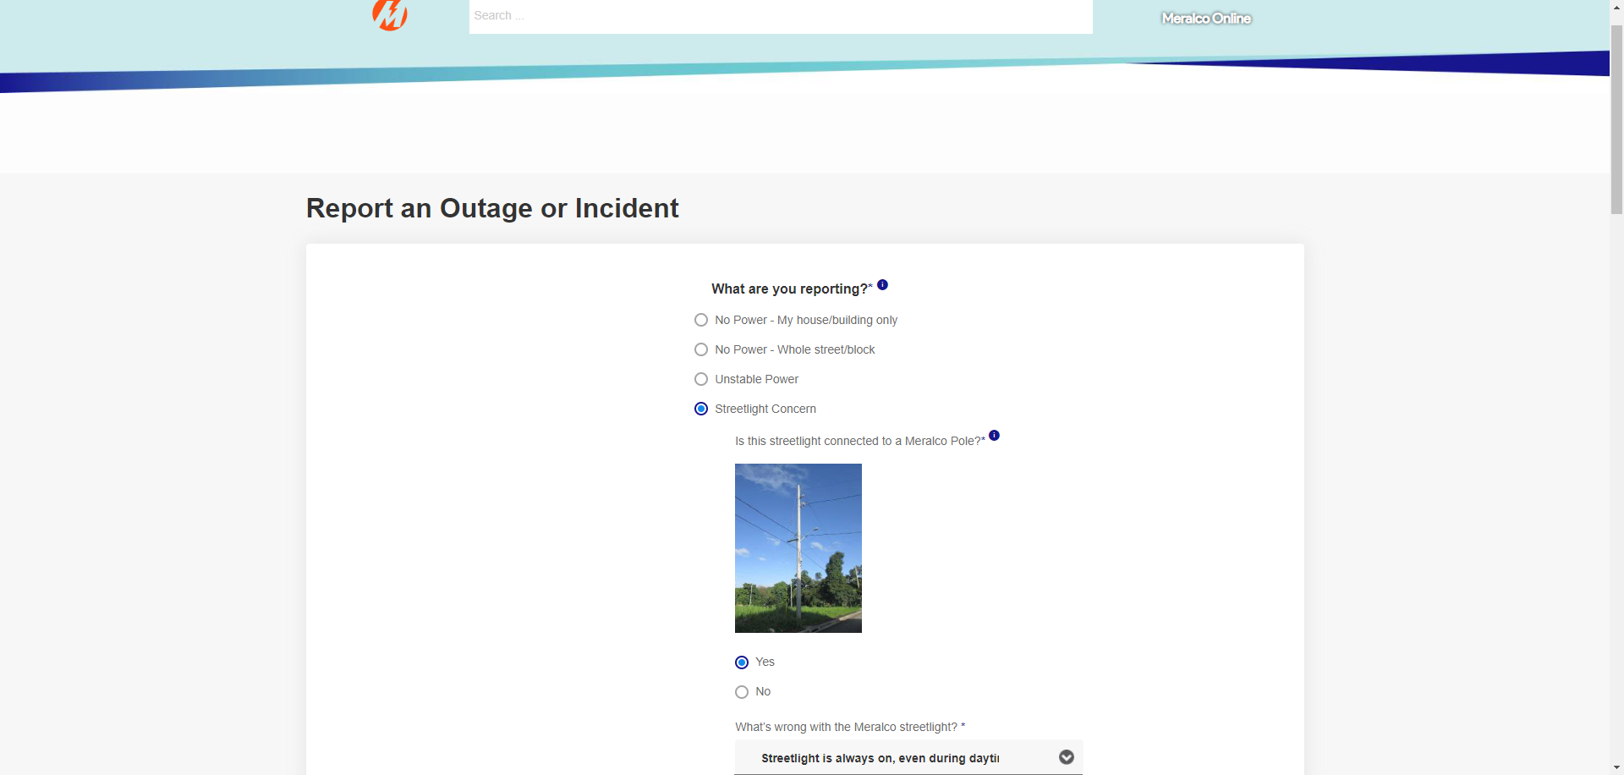

|  |
| --- |
| Step 21 - Populate the following fields by selecting from one of the picklist values, as applicable: - Province - City/Municipality - Barangay - Subdivision - Street - House/Unit No./ Floor/ Building |
| Fields should be populated. |



|  |
| --- |
| Step 22 - Populate 'Pole Number' field using the values encoded in the prior report. |
| Fields should be populated. |

